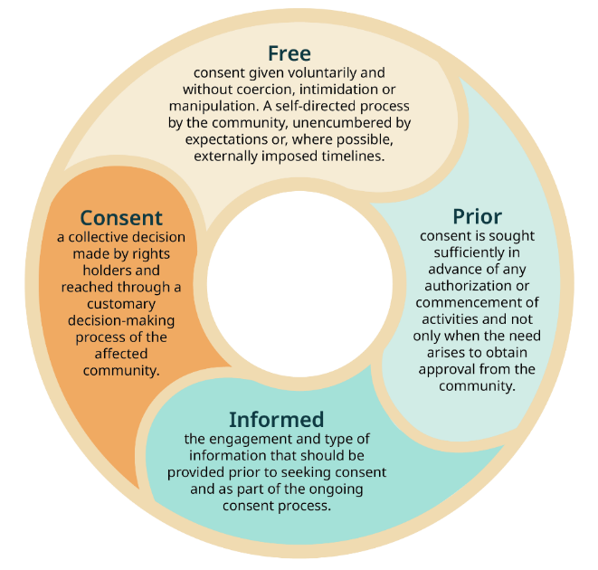
Free, Prior and Informed Consent (FPIC) Form for Consultation
We acknowledge the Traditional Custodians of the land where this project takes place, and we pay our respects to Elders past and present, and emerging.
We acknowledge that cultural authority on Country rests with the Traditional Custodians connected to this place.
When we work on Country, we will follow all cultural, gender-based and community-specific protocols shared with us, and we welcome guidance on any obligations or expectations we must follow.
Infographic sourced from: DCCEEW 2025, First Nations
Engagement: the principles of Free, Prior and Informed
Consent, DCCEEW 2025, licensed under CC BY 4.0

1. Project Overview
Project Title: Click or tap here to enter text.
Client: Click or tap here to enter text.
Facilitator/Consultant: Click or tap here to enter text.
Location: Click or tap here to enter text.
Project Description:Click or tap here to enter text.
We’re working with you to understand the cultural heritage values on your Country following your cultural protocols. This may include site visits, mapping, interviews and stories.
This form covers work done by the consultant for this project only.

2. Free, Prior and Informed Consent:
We are asking to work with Traditional Custodians to support the protection and accurate representation of your cultural heritage values, following your cultural protocols.
We want to:
- Learn about connections to Country;
- Understand cultural heritage values and stories;
- Make sure cultural protocols are respected and followed; and
- Include Traditional Custodian knowledge (with consent) in reports or interpretation.

3. How the Consultation Will Happen
- We will provide information about the project and its purpose;
- With your consent we will meet with you (on Country if appropriate) to hear your views and record what you choose to share;
- We will provide the draft materials to you for comments before anything is finalised.
- Participation is voluntary and you may stop at any time;
- We will provide you with a copy of any final reports; and
- We will follow any cultural protocols around the protection of restricted information.

4. Cultural Knowledge, ICIP and Data
Indigenous Cultural and Intellectual Property (ICIP) is the cultural knowledge, heritage and expressions that belong to Aboriginal and Torres Strait Islander peoples.
Indigenous Data Sovereignty and Governance refer to the rights of Aboriginal and Torres Strait Islander peoples to control data about themselves, their communities and their Country, and the protocols that put those rights into practice - how data is collected, stored, accessed, shared and used.
- All cultural knowledge, stories, images, recordings and site information remain the cultural property of the Traditional Custodians;
- With your consent, the consultant will use this knowledge only for the purposes ticked below; and
- All cultural knowledge, recordings and data will be managed in line with Indigenous Data Sovereignty and Indigenous Data Governance principles. Traditional Custodians may request access to or removal of their data at any time, and we will store and use it only in accordance with the cultural protocols and restrictions identified.

5. Your Time and Fees
We advocate to the client that you are paid fairly for your time and cultural knowledge. We ask the client whether they will pay you directly or by us. Please invoice for your time to: Click or tap here to enter text.
What is your hourly rate: $Click or tap here to enter text.
NOTE: For Aboriginal Cultural Heritage Assessment (ACHA) and Aboriginal Heritage Impact Permit (AHIP) projects in NSW, payment is generally only available to Aboriginal parties formally registered for the commercial assessment phase, not for earlier consultation stages. We acknowledge this can fall short of recognising the value of your time and knowledge, and we will advocate to the client wherever possible for fair compensation.

6. Your Preferences and Consent
Confidentiality and Identification:
Please select how you want to be identified:
☐ You may use my name.
☐ You may use my community/group name
☐ Keep my name private;
Preferred wording: Click or tap here to enter text.
Secret, Sacred or Restricted Information
Please tick if any restrictions apply:
☐ Men’s business only.
☐ Women’s business only.
☐ Some information I share is restricted. I do not want my details shared with other people
Details/conditions:Click or tap here to enter text.
Secret or sacred material will not be published or shared, and we will observe all gender, cultural and community-specific restrictions, unless disclosure is required by law.
Recordings, Photos and Mapping (Tick Yes/No)
Please indicate consent:
Photos: Yes ☐ No ☐
Video: Yes ☐ No ☐
Audio recordings: Yes ☐ No ☐
Written stories/quotes: Yes ☐ No ☐
Mapping/GIS/site data: Yes ☐ No ☐
How your knowledge may be used:
Please tick Yes/No for each use:
Internal project work: Yes ☐ No ☐
Reports (internal): Yes ☐ No ☐
Reports (public): Yes ☐ No ☐
Academic publications: Yes ☐ No ☐
Websites/social media: Yes ☐ No ☐
Media (news, TV, radio): Yes ☐ No ☐
Education materials: Yes ☐ No ☐

7. Your Rights
- You don’t have to take part;
- You can stop at any time;
- You can ask for copies of anything you’ve shared;
- You can tell us how your information should be used, stored or shared;
- We won’t share your knowledge without your clear permission;
- You may ask questions at any time;
- You can change your mind or limit what you share at any time during the consultation process before any final reports are submitted. Where reports have already been finalised, we will work with you to address your concerns to the extent practicable; and
- If you have concerns, want to change your consent, or wish to withdraw information, you can contact the facilitator at any time.

8. Consent
☐I give my free, prior and informed consent to take part in this project consultation
☐I would like a copy of this form and anything I share
Format preferred: Email ☐ Printed ☐
Your Name:Click or tap here to enter text.
Community or Role:Click or tap here to enter text.
Signature:Click or tap here to enter text.
Date:Click or tap here to enter text.
Contact (optional):Click or tap here to enter text.

Facilitator Details
Facilitator Name: Click or tap here to enter text.
Organisation / Role: Click or tap here to enter text.
Signature:Click or tap here to enter text.
Date:Click or tap here to enter text.
You may contact this person at any time to ask questions or change your consent

