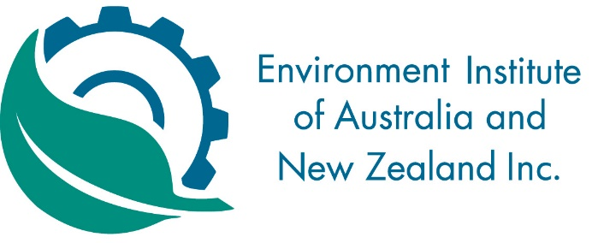

NT DIVISION
ANNUAL GENERAL MEETING – WEDNESDAY 23 AUGUST 2017

NOTICE

The Annual General Meeting of the Environment Institute of Australia and New Zealand (NT Division) will be held on Wednesday 23 August 2017 at the Darwin Sailing Club, Atkins Drive, Fannie Bay.

- The AGM will begin at 5:30pm and is expected to conclude by 6:30pm
- Light refreshments will be provided

AGENDA

- Apologies
- Confirmation of Minutes of 2016 AGM
- President’s Report
- Treasurer’s Report
- Councillor’s Report
- Election of Divisional Committee
- Other Business

