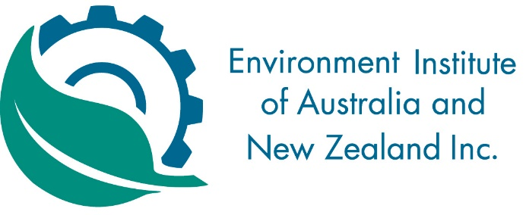

Western Australian Division of EIANZ
ANNUAL GENERAL MEETING – Wednesday 16th August 2017

NOTICE

The Annual General Meeting of the Environment Institute of Australia and New Zealand (Western Australian Division) will be held on Wednesday 16th August 2017 at the VIP Suite, Emerson Bar, 356 Murray Street, West Perth

- The AGM will begin at 6pm and is expected to conclude by 7pm.

AGENDA

- Apologies
- Confirmation of Minutes of 2016 AGM
- President’s Report
- Treasurer’s Report
- Councillor’s Report
- Election of Divisional Committee
- Other Business

